Steps to reschedule normal programs:
- Open request in failed responsibility.
- Click on rerun request.

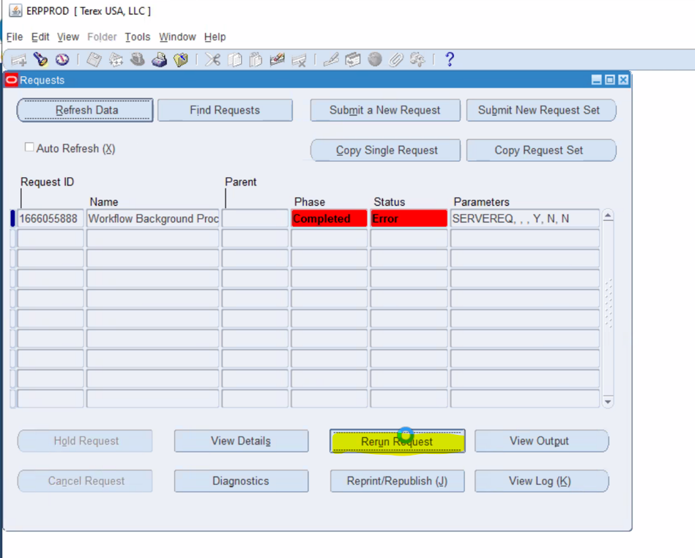
- Click on schedule
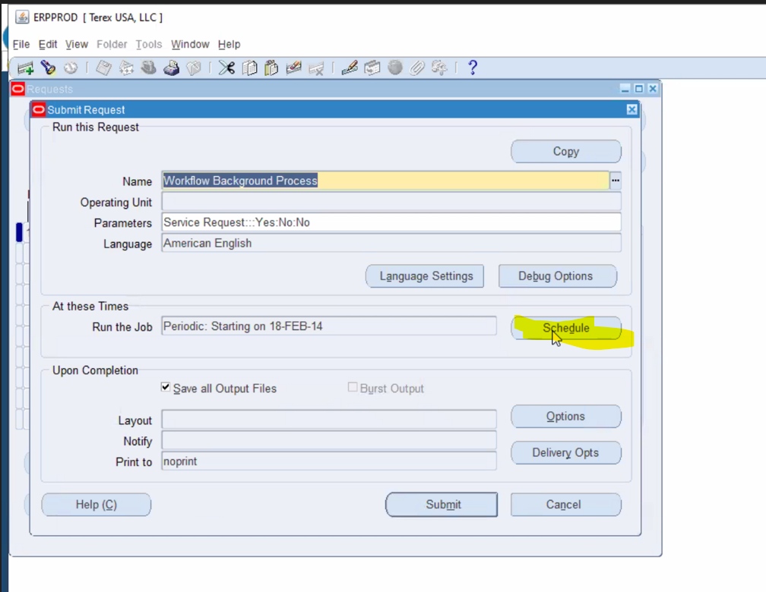
- Click on Start Date
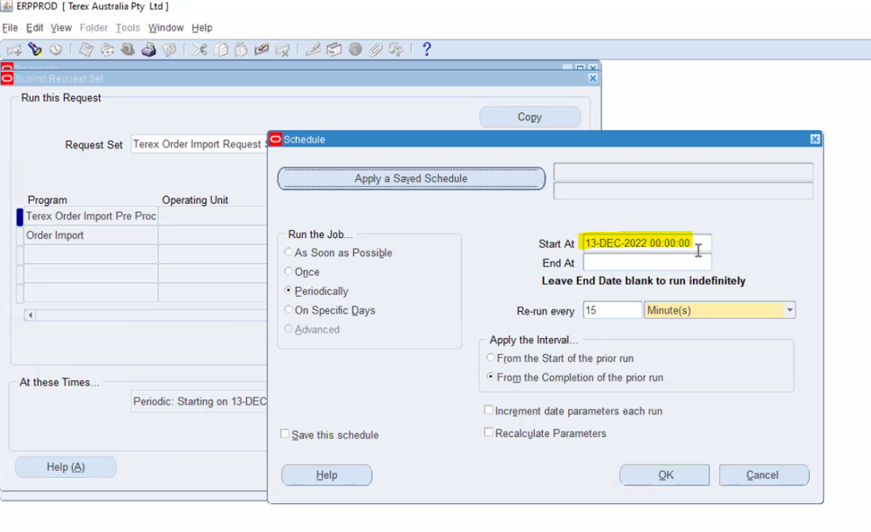
- Choose present date and specific time zone.

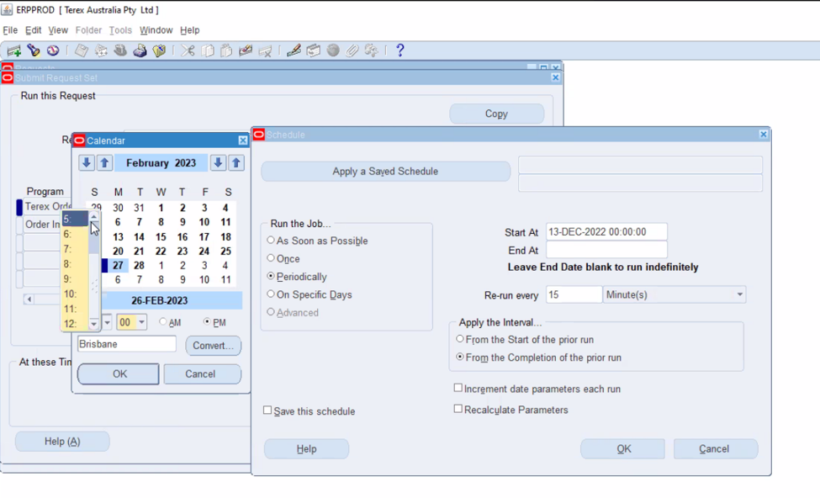
- Leave End At blank and click OK.
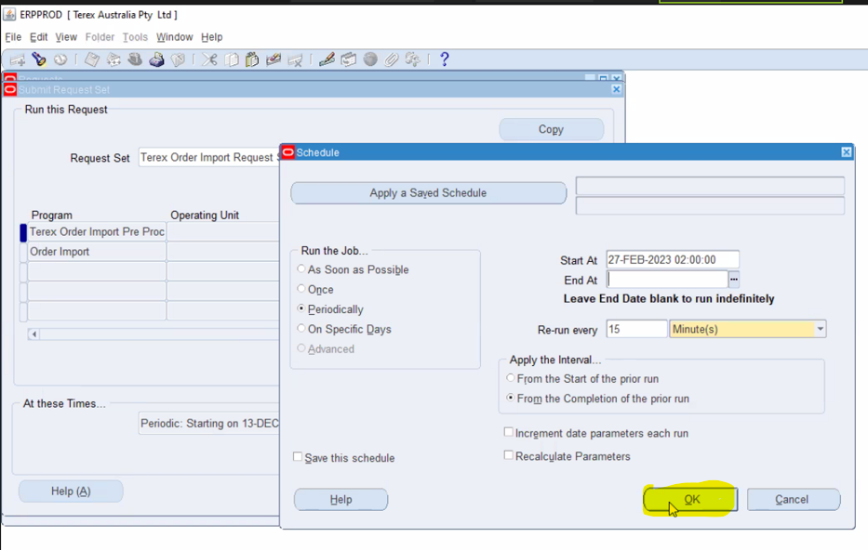

- Click on Submit.
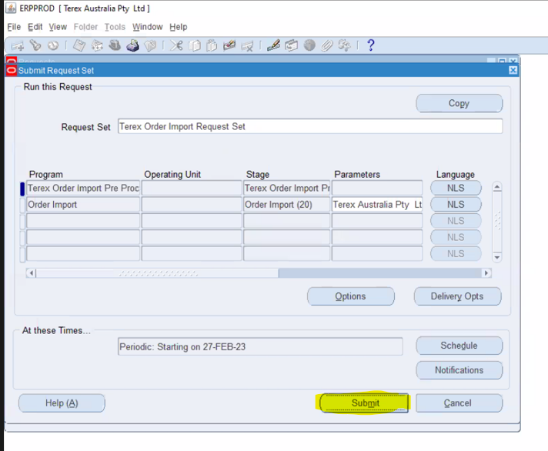

- Wait till you see below page. (If it takes more than 3 or 5 mins then close your java page from task Manager)
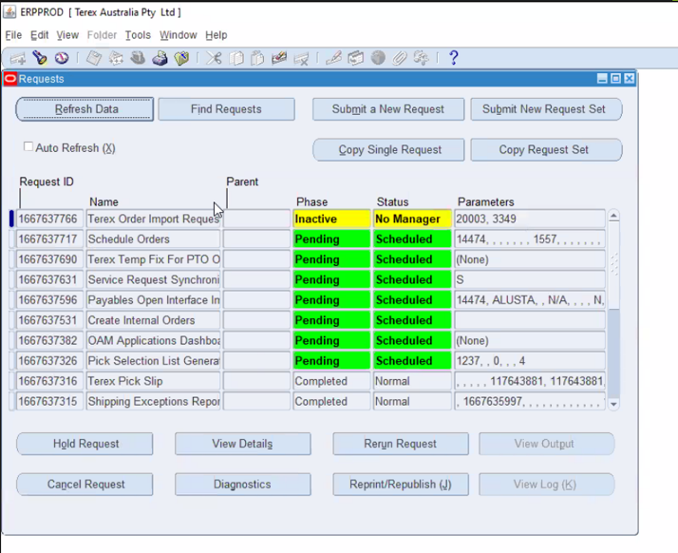

- Repeat the process same with remaining requests.

